OSManagement with ORM stacks

Contents

1. Introduction 2
2. Workflow diagram to deploy the stack 3
3. Create stack for the OSManagement “Default Domain” 4
4. Plan the Job 8

Introduction

This resource provides the Managed Instance Management in Oracle Cloud Infrastructure OS Management service. The resource can be used to attach/detach parent software source, child software sources and managed instance groups from managed instances.
Adds a parent software source to a managed instance. After the software source has been added, then packages from that software source can be installed on the managed instance. Software sources that have this software source as a parent will be able to be added to this managed instance. Removes a software source from a managed instance. All child software sources will also be removed from the managed instance. Packages will no longer be able to be installed from these software sources.
Adds a child software source to a managed instance. After the software source has been added, then packages from that software source can be installed on the managed instance.
Removes a child software source from a managed instance. Packages will no longer be able to be installed from these software sources.
Adds a Managed Instance to a Managed Instance Group. After the Managed Instance has been added, then operations can be performed on the Managed Instance Group which will then apply to all Managed Instances in the group. Removes a Managed Instance from a Managed Instance Group.
NOTE The resource on CREATE will detach any already attached parent software source, child software sources, managed instance groups to the managed instance. Destroying this resource will not delete any associations.

Workflow diagram to deploy the stack
Below diagram shows how the Terraform Artifact are applied in the OCI. While creating a ORM stack, using terraform deliverables Init, Plan and Apply is the flow to provision the resource in the OCI. We can have the deliverables in any of below.
- GitLab/GitHub Repo
- Bitbucket
- Can be in folder/.zip in the local disk
- Object Storage Bucket
- Can be in compartment
- Oracle provided Template

Pre request:
- The OSMS Should enabled in the tenancy
- SSH Key

Create stack for the OSManagement “Default Domain”

Go to OCI Console Developer Services Resource Manager Stacks select the compartment Create Stack

My Configuration Folder Browse Select the “osmanagement” folder that contains the terraform Upload

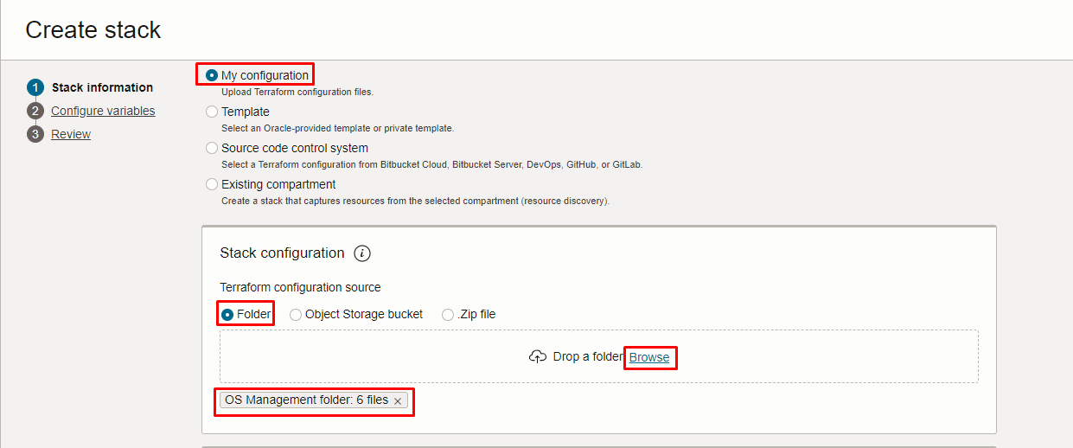
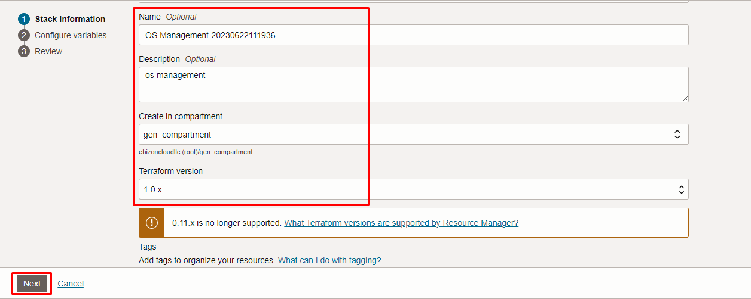

Click “NEXT”

Select the parameters as per the below screen,

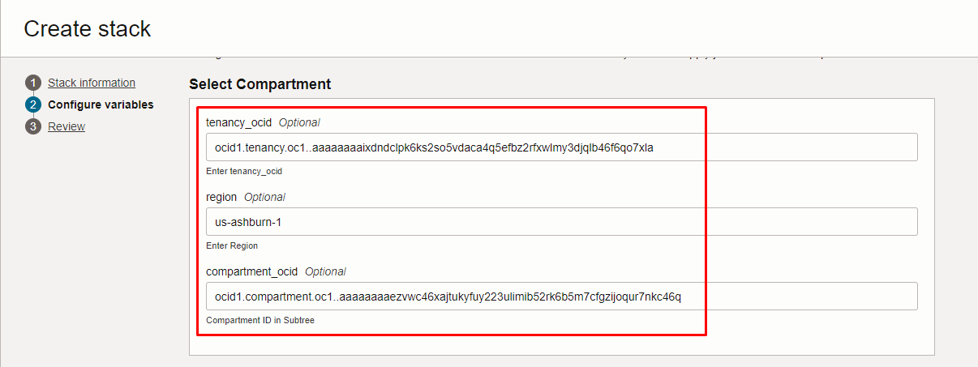
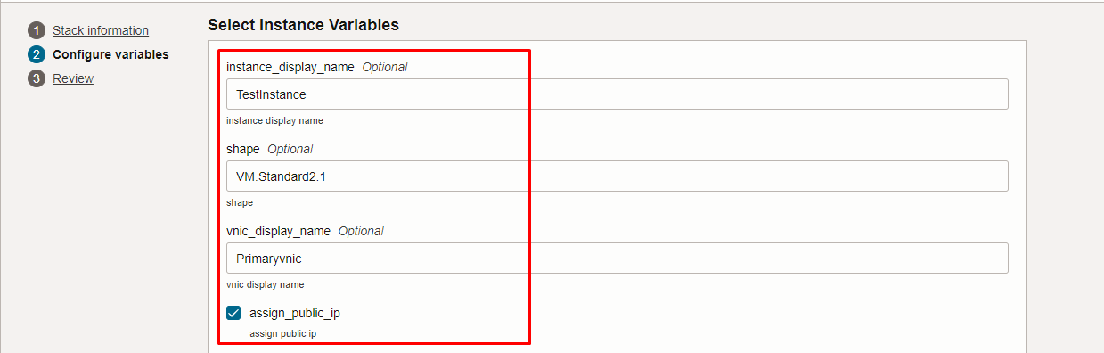
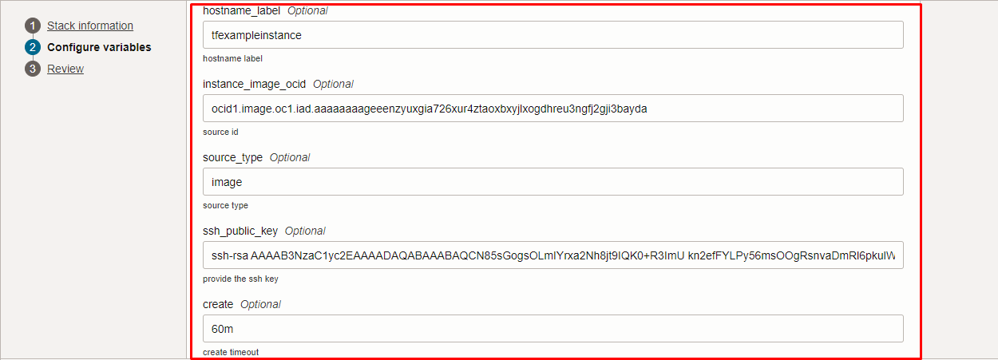
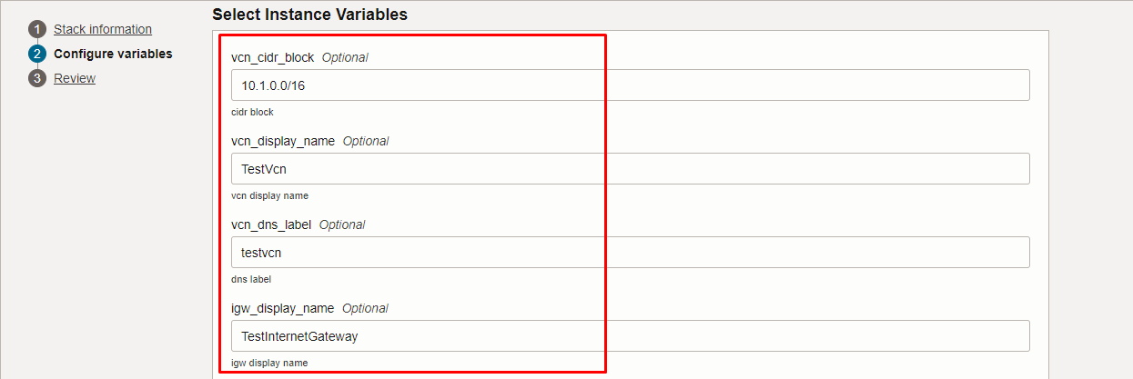
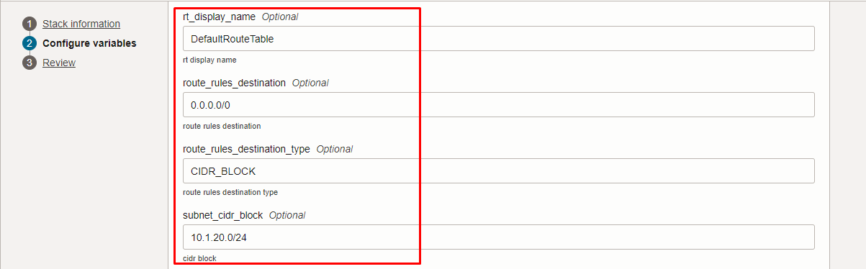
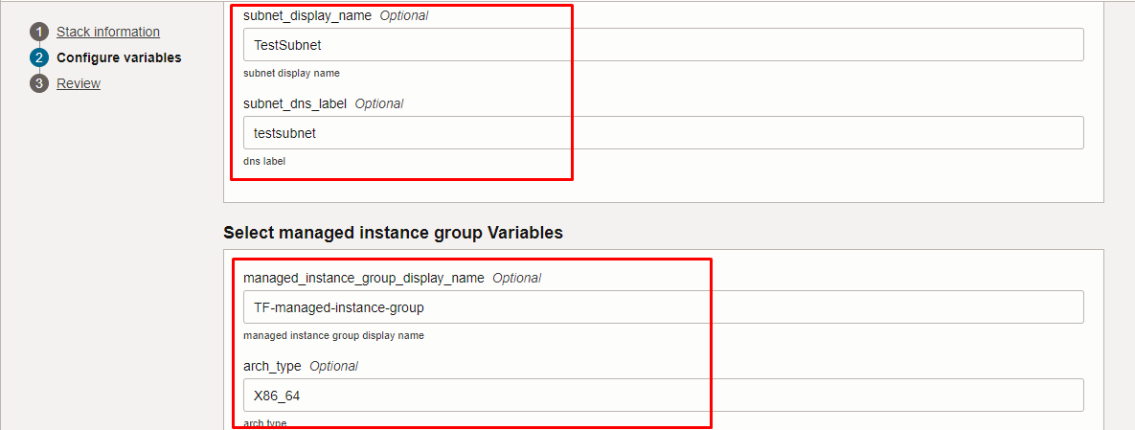
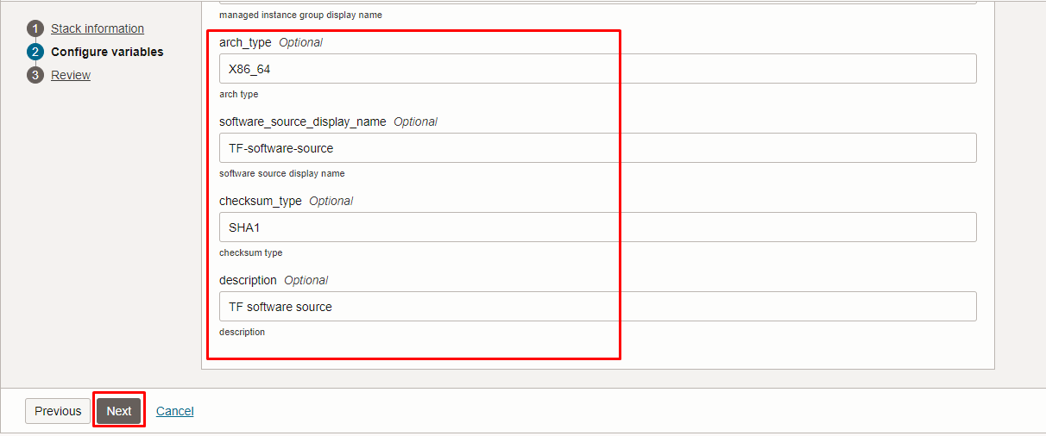

Click “NEXT” Click “CREATE”

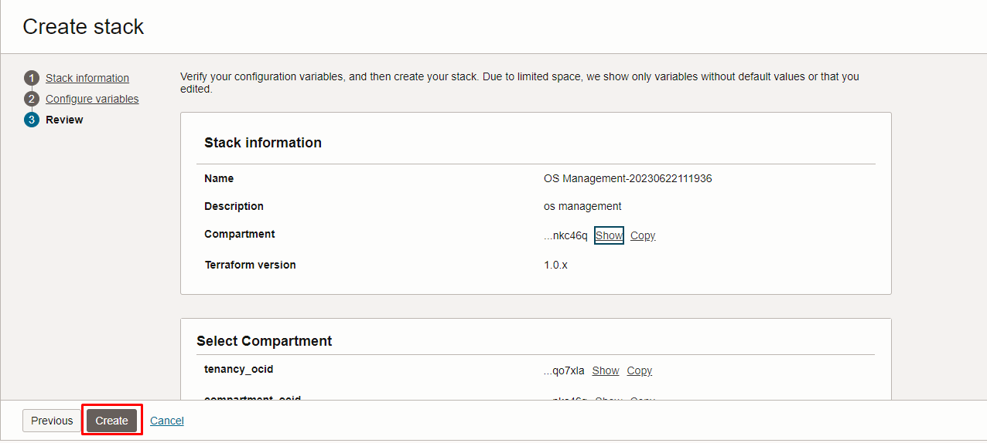

Plan the Job

Click the “Plan”

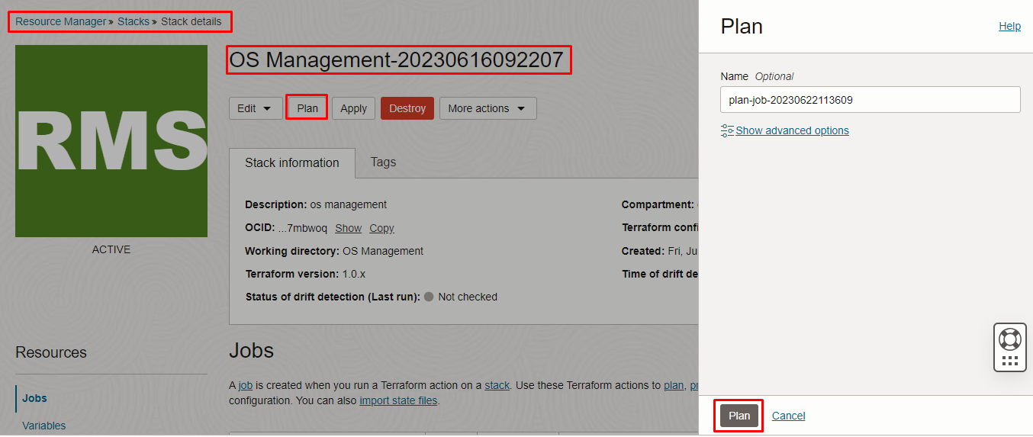

Verify the Plan is successful.
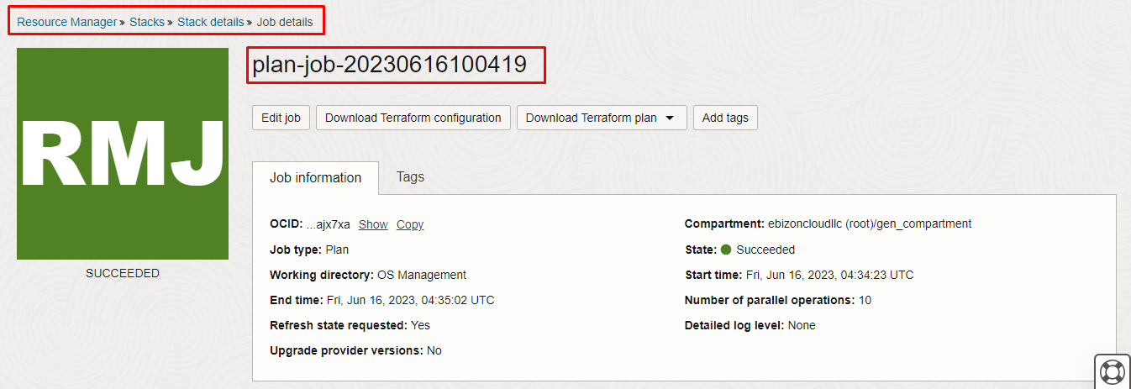

#####END#####

